**DAY 3 CHEAT SHEET**

Morse Code Guide

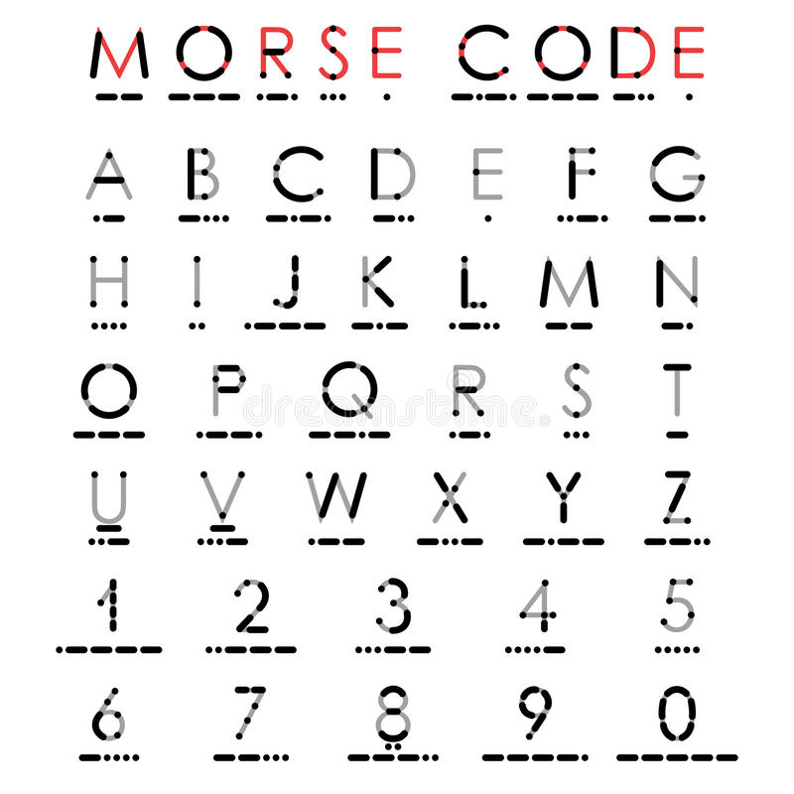

Morse Code Translator Circuit

